Nicholas Snyder

Ms. Desrosiers

ENGL 401.03

1 December 2020

* Summarize your survey responses. You may want to include some basic statistics.

|  |  |  |  |  |  |
| --- | --- | --- | --- | --- | --- |
| Q2 | Q4 | Q6 | Q7 | Q8 | Q9 |
| 11yes | 19yes | 2yes | See plot | 10state | 15yes |
| 10no | 2no | 11no |  | 6federal | 5no |
|  |  | 8maybe |  | 2union |  |

<https://forms.gle/Gu2psadswAyhU6i59>

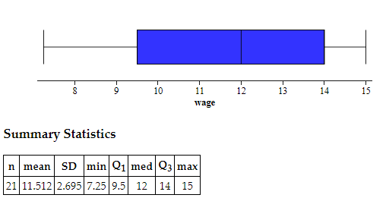

* Reflect on what you learned from the results. Did you learn about a different audience or position in the debate? What do they tell you about how to persuade your audience? What did you learn from this data? What further research might you do? Etc.

I had 21 responses after 23 hours after posting it to my snapchat and Instagram. I did not take it myself. Most of the responses were from people who live in NH and all said to have had or do have a job. A lot of the responses were in favor for a minimum wage above $10, which I am not. Most people would like to get paid more (Q2), most people would like to raise the minimum wage (Q4), most people would have each state decide its minimum wage (Q8), most people think a minimum wage should equal a living wage (Q9). Question 7 I asked what they would set a minimum wage at. The average response was about $11.50/hr. I like that I asked people to offer a counter argument to their stance. Many people said that it may negatively impact small business. If I were to do it again, I would ask each person’s age to add to a demographic. More responders would also bode better results.